**IM Chain has strong landed in South Korea to create a new tuyere with “intelligent manufacturing + block chain”**

Intelligent Manufacturing Chain (IM chain) project is going to publish in 2018 TOKENSKY blockchain Conference Seoul Session. IM Chain, which based on block chain techniques and integrates intelligent manufacturing techniques, focusing on the creating of personalized super factory for each individual.

IMChain has been received widely attention in many industries. At this conference, it will bring the technological strength to the public and set off a technology storm through combination of intelligent manufacturing and block chain. 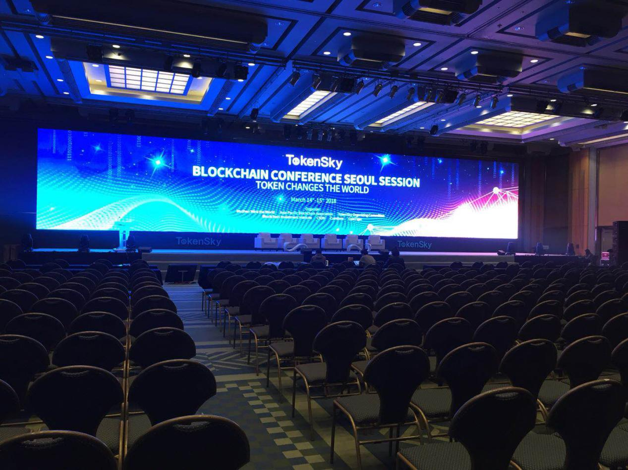

**International tuyere this year: block chain + intelligent manufacturing**

The trend of economic globalization has never been stopped, and the core driving force to accelerating this process is the combination of intelligent manufacturing and block chain technology.

Technology will always be the first driving force for the development of economic. The current economic development has met the bottleneck, hence every country is eager to seize this opportunity. Block chain is a decentralized storage database, which can assist the development of intelligent manufacturing industry. It is also the first project in the world to integrate intelligent manufacturing with block chain technology.

Recently, the trend of block chain plus intelligent manufacturing has been spread globalized. The distributed technology represented by the block chain is the basic underlying technology of the fourth industrial revolution. IM Chain, which integrates industrial Ethernet technology, artificial intelligence technology, 3D printing technology, whole life cycle management technology and block chain technology, create a digital twin for the physical world, and established a new type intelligent production distributed network, and bring disruptive change to the traditional manufacturing industry. The IM chain is going to show the new ecosystem in this conference.

It is what we called metaphysics that only research simple theory and technology and do not apply in real scene, because the implementation of technology will bring us the future. The advent of block chain technology has undoubtedly brought about science and technology for future.IM Chain will truly achieve the technology application，make this techniques storm sweep to the world.

**Introduction of the 2018 TOKENSKY block chain Conference Seoul Session in 2018**

14th March, the 2018 TOKENSKY Block chain conference Seoul Session is grand opening. As the most professional Token economic and Block chain industry conference, world top economists, scholars, financiers, investors, geeks, industry leaders, Block chain related enterprises, exchanges, service providers, media, and TOKEN fans has been invited in Seoul，to focus on the issues, opportunities and challenges facing with Block chain field.

**Conference** **website :** [**www.TokenSky.net**](http://www.TokenSky.net)

**Telegram telegraph group ：**[**https://t.me/TokenSky**](https://t.me/TokenSky)

**IMChain website : imchain.in**

